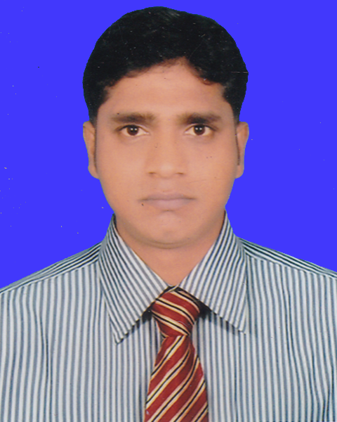
Md. Mokarram Hossain
Mailing Address: Helal Book Deport
Daratana, Jessore-7400.
Contact Number: Cell- 01924-494534 Email: mokarramhossain933@gmail.com
Career Objective :
To develop a career in dynamic and challenging environment, where hard work, strict discipline and sincerity are welcomed. I have a desire to give my full effort in the job so that the company can make profit that will facilitate achieving my own goal too.
Educational Qualification :
2012 Masters of Business Studies (M.B.S)
Sub : Management.
University : National University
Institute Name : Gov't Bangla College
Year of Passing : 2012
Result : 2nd Class
2011 Bachelor of Business Studies (B.B.S)
Sub : Management
University : National University
Institute Name : Chuadanga Govt. College
Year of Passing : 2011
Result : 2nd Class
2007 Higher Secondary Certificate (H.S.C)
Group : Business Studies
Board : Jessore
Institute Name : Darsana Govt. College
Year of Passing : 2007
Result : GPA 3.80 (Out of 5.00)
2005 Secondary School Certificate (S.S.C)
Group : Business Studies
Board : Jessore
Institute Name : Memnagar B.D. High School
Year of Passing : 2005
Result : GPA 3.69 (Out of 5.00)
Experience :
Total Experience of 4 years
- Post : Supervisor (Event Management)
Company : Pran RFL Group Location : 105, Middle Badda, Dhaka.
- Territory Sales Officer of One Publications at 260, Malibagh, 5th floor, Dhaka - 1217.
- Now I am working as a Territory Sales Officer of Lecture Publications at Razzak Tower (5th floor), 5 Purana Paltan, Dhaka-1000
Extra Curriculam Activities :
Precipitated in different cultural in the University, College & School level.
Computer Proficiency :
Good Command in Computer Operating and Data Processing, Proficient in MS Word/Excel/Power Point, E-mail & Internet Browsing.
Language :
Excellent reading, writing and speaking abilities both in English & Bangla.
Field of Interest :
Watching TV News, listening to music, travelling.
Personal Details :
Father’s Name | : Md. Abul Kashem
Mother’s Name | : Shahor Banu
Date of Birth | : 01 January 1990
Nationality | : Bangladeshi by Birth
Religion | : Islam (Sunni)
Marital Status | : Married
Permanent Address | : Vill- Ajimpur, P.O- Darsana,  P.S- Damurhuda, Dist- Chuadanga.
Reference :

- Md. Masudur Raman
PS To MD
Grameen Shakti,
Grameen Bank Bhaban ,
(19th Floor), Mirpur-2, Dhaka - 1216. Cell: 01722398460
E-mail: parvez.ne.en@gmail.com
- Tuhin Mohammad Sazib

(Md. Mokarram Hossain)
Date :

Territory Sales Officer,
(Kustia)
R.B Group, Walton Mobile
Cell : 01913-334372

